# Data analytics for home appliances identification

Ayush Garg, Gabriel Vizcaino, Pradeep Somi Ganeshbabu

Energy, Science, Technology and Policy  
Carnegie Mellon University, Pittsburgh, PA 15213

**ABSTRACT**

In this paper, we identify home appliances using the voltage and current data obtained from different smart meters. A public dataset of high resolution for load identification research called is used PLAID for the analysis. The voltage vs current profile is used to create features and identify the appliances. The PLAID dataset comprises of current vs voltage profile for the 1074 appliances (of 11 types) for a duration of about 5 seconds. Different multi-class classifiers are trained and tested on the dataset in order to identify the most accurate and computationally inexpensive model. An image classification approach of Voltage-Current profiles in steady state is used to model the inputs of the appliance classifiers. Based on the analysis undertaken the 11 unique appliances are identified using multiple classifiers while their performance is compared in terms of time and accuracy. After fine tuning their corresponding parameters on a training sub-set, the average accuracy of KNN and RF, applying 10-fold cross-validation, is greater than 91%. The One-vs-the-rest and Gradient Boosting Decision Trees classifiers also show high accuracy; however, the fitting time is in the order of minutes (almost 15 min. for Gradient Boosting), whereas KNN and RF take seconds to do the job. Though KNN scores slightly higher than RF, the latter takes significantly shorter fitting time (about 8x time less). While high accuracy in both classifiers is achieved using traditional cross-validation techniques, when applying cross-validation for individual home, the accuracy decreased to 80% on average.

**CCS Concepts**

Energy management- Data driven building energy management

**Keywords**

Classifiers; Load disaggregation; NILM; Load identification

# INTRODUCTION

The energy consumption in the residential and commercial account for 41% of the total energy consumed in the United States [1]. This growth can be attributed to a list of appliances like ceiling fans, fume hoods, vending machines, televisions, computers etc. These loads are termed as Miscellaneous Electrical Loads (MELs). The primary energy consumption of the MELs is expected to grow from 6.1 quads to 6.9 quads in residential buildings and from 6.5 quads to 8.3 quads for commercial buildings [2]. The 2015 Annual Energy Outlook has projected a growth of 13% in residential MELs primary energy consumption from 2016 to 2030 and a 27% increase in commercial buildings during the same period [2]. Growth of MEL has resulted in offset of some of the efficiency gains and improvement in standards of major end use appliances like space conditioning, lighting, and water heating.

For this analysis, we have used a public dataset, Plug-Load Appliance Identification Dataset (PLAID). In this dataset the current and voltage measurements are sampled at 30 kHz for 11 different appliance types. More than 200 different makes and models of the 11 different types are used, which are present in the 55 households in Pittsburgh. A similar work on the PLAID data is done by [3], achieving 86.03% average accuracy across different classifiers, when training and testing with different appliances.

# EXPERIMENT STEPS

Before doing the analysis the the transient state and the steady state of the appliances were segregated. It was observed that the last 30,000 data points of each device measurement consisted mainly of the steady state period. Through exploratory data analysis, we found that 505 data points make one cycle. With 30,000 data points that translates to around 60 cycles for each appliance. A mean of all these cycles was taken as the representative cycle for each appliance. After calculating the steady state cycles for each appliance measurement, we plotted the current vs voltage for five random appliances of each type. Based on these values we plotted the current and voltage profile of each appliance for the last ten steady state periods. This is show in figure 1. From the V-I plots above we can conclude that, especially in the steady state, the combination of linear and non-linear elements within each appliance type produces a similar pattern of voltage vs. current across appliances of the same type. Though not perfectly consistent, we can harness this characteristic in order to build features that help us classify an appliance given its voltage and currents signals. Since the classification results were better with just the last cycle of each measurement i.e. the last 505 points we decided to go with that approach

We explored different transformations to extract features from voltage and current signals like directly using the voltage and current values, calculating the Fourier transform of the current to identify harmonics, descriptive statistics (e.g. standard deviations and variation coefficients over a cycle) and printing images of V-I plots in order to extract the pixels’ characteristics. While all of them provide useful information to identify appliances, the latter (i.e. images) is the transformation that yields the highest predicting accuracy. Therefore, we stick with this approach in this paper.

To get the images for each appliance measurement we normalize the current and voltage data of the last cycle (assuming it is steady state) and store the current vs voltage plot as images for each individual appliance. After loading the images as arrays, with each image being 180 X 180 pixels, a matrix is creating which is our feature matrix.

To build a well-performing classifier that identifies the appliance type based on its voltage and current signals as inputs, particularly the V-I profile at steady state, we start by evaluating different multi-class classifiers on the features matrix. To prevent over-fitting, the dataset is randomly divided into three sub-sets: training, validation, and test. The models are fitted using the training subset and then the accuracy is tested on the validation subset. After this evaluation the best models are fine-tuned and then tested using the testing subset. Since the objective is to accurately identify the type of an appliance based on its electrical signals, the following formula is used to measure accuracy [4]:

Accuracy (Score) = $\frac{Number of positive predictions}{Number of predictions}$

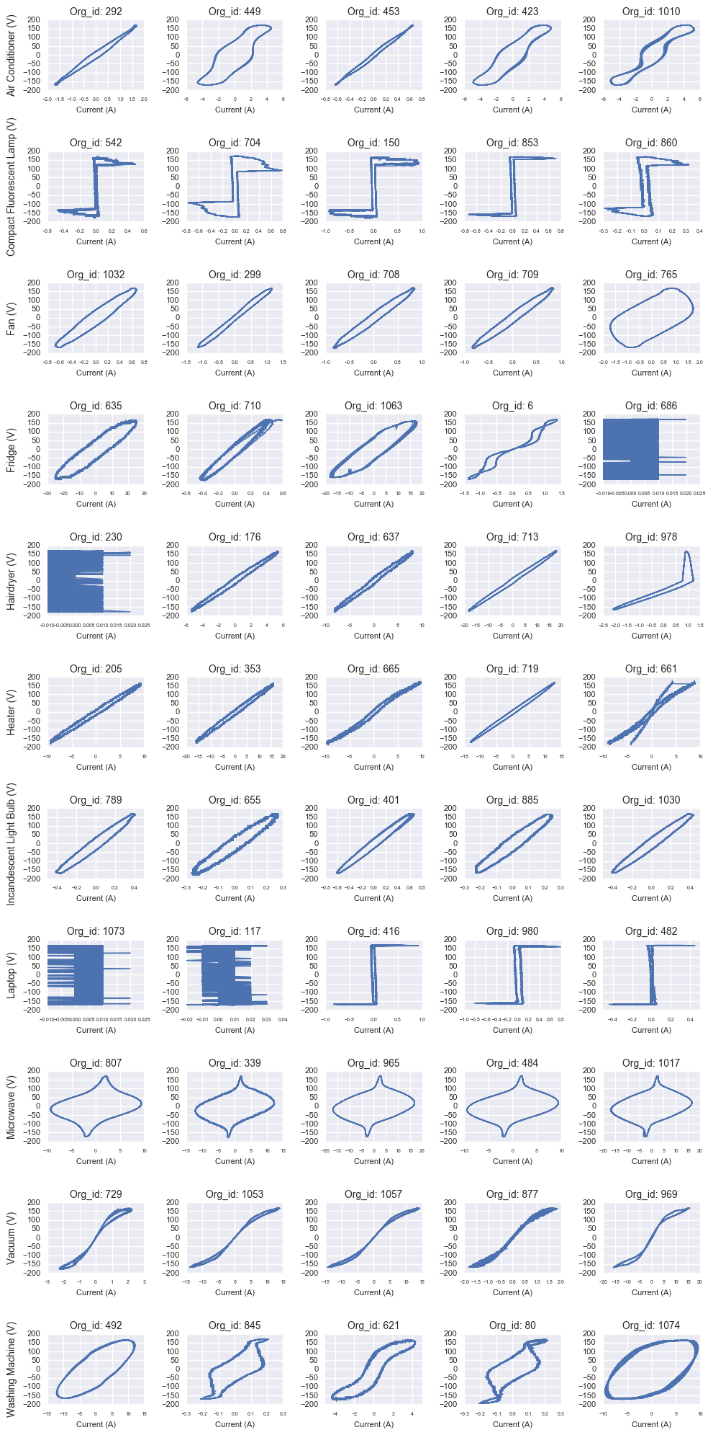

**Figure 1 V-I curve for last ten steady state periods**

# RESULTS

In general, the evaluated classifiers showed remarkable accuracy over the default classifier (random selection) - expect for the Naive Bayes classifier using Bernoulli distributions. The one-vs-the-rest model, using a support vector machine estimator, showed the highest accuracy on the validation subset. However, this classier, along with the Gradient Boosting (which also presents a good performance), takes significantly more time to fit than the others. On the contrary, the K-nearest-neighbors and Random Forest classifiers achieve high accuracy and are also computationally faster. For these reasons, we are going to fine tune the main parameters of the latter two classifiers, re-train them, and then test again their performance on the testing subset. Table 1 shows the results of the various classifiers used.

Table . Different classifier accuracy and time

|  |  |  |
| --- | --- | --- |
| **Classifier** | **Accuracy** | **Time(s)** |
| One-Vs-Rest | 0.9012 | 262.054 |
| Extra Tree | 0.7326 | 0.144 |
| Decision Tree | 0.8023 | 1.642 |
| Gaussian NB | 0.5058 | 1.566 |
| Bernoulli NB | 0.157 | 0.551 |
| Gradient Boosting | 0.843 | 822.472 |
| k-Neighbor | 0.8779 | 8.883 |
| Random Forest | 0.8547 | 0.369 |

## Parameter tuning

For the KNN classifier, the above graph suggests that fewer the number of neighbors to consider, better is the accuracy. Therefore, we are going to set this parameter to have only one neighbor in the KNN classifier. Having this new parameters, the training and validation sub-sets were retrained for both the classifiers, and test the model on the testing set. Figure 2 shows us how the accuracy changes with number of neighbors.

Although the characteristic of the Random Forest classifier entails that the shape of the above graph changes every time it is run, the general behavior suggests that having more than 10 sub-trees notably improves the performance of the classifier. Progressively increasing the number of trees after this threshold slightly improves the performance further, up to a point, around 70-90, when the accuracy starts decreasing. Therefore, the number of parameters is limited to 80 sub-trees. Figure 3 Table 2 shows the results after fine tuning the parameters.

Table 2. Classifier results after fine tuning parameters

|  |  |  |
| --- | --- | --- |
| **Classifier** | **Accuracy** | **Time(s)** |
| k-Neighbor | 0.9116 | 9.546 |
| Random Forest | 0.884 | 1.468 |

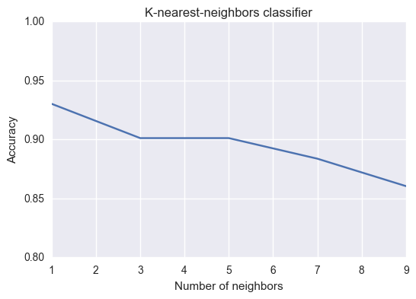

**Figure.2-Change in accuracy with changing number of neighbors** 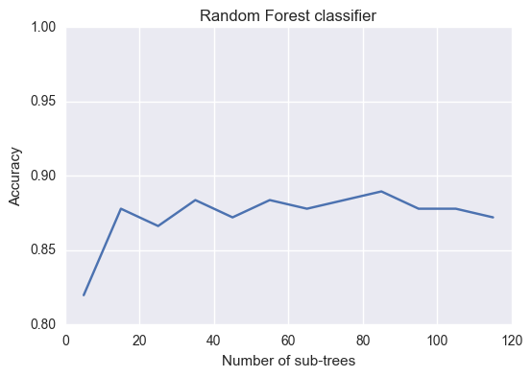

**Figure.3-Change in accuracy with changing number of subtrees**

Both classifiers showed improvement in performance after the tuning of parameters. KNN also outweighs the performance of the one-vs-the-rest classifier. Although the score of the Random Forest classifier slightly lags behind KNN, this fitting time is 8x times faster than KNN. To further test the performance of both classifiers, a random 10-fold cross-validation process was used on both models using the whole dataset.

Table 3. Classifier results after fine tuning parameters

|  |  |  |
| --- | --- | --- |
| **Classifier** | **Average score** | **10-fold CV time(s)** |
| k-Neighbor | 0.934 | 76.215 |
| Random Forest | 0.92 | 20.065 |

The results from the 10-fold cross-validation were very promising with both models showing more than 92% average accuracy and though KNN scores slightly higher, Random Forest still shows significantly lesser fitting time.

## Identifying appliance type per house

Another approach to test the performance of the KNN and Random Forest classifiers would be to isolate one of the houses for testing and training the model on data from rest of the houses. This would ensure the robustness of the load identification model. There are 55 homes surveyed and each appliance has a label indicating its corresponding house; hence, it is possible to split the data in this fashion. This is another way to cross-validate.

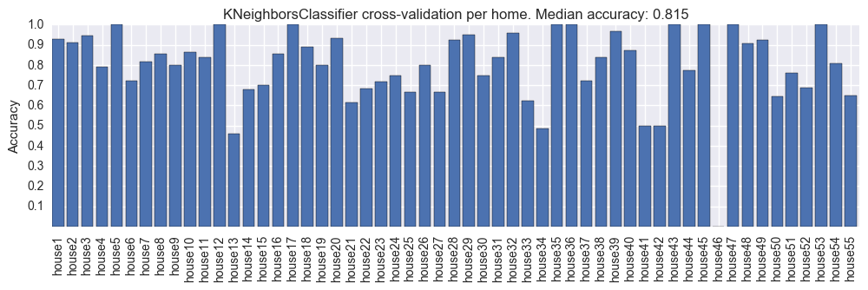

**Figure 4- k-Neigbours classification per house**

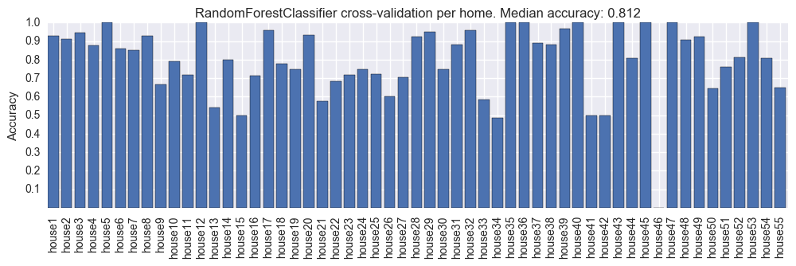

**Figure 5 – Random Forest classifier per house**

Figure 4 and Figure 5 show results of the cross-validation per home and a median accuracy above 80% for both classifiers. Out of the 55 home appliance predictions, 9 scored 100% accuracy and around 20 had scores above 90%. Only three and two houses had a scored below 50% using KNN and RF respectively. In general, the presented outcome suggests that the chosen classifiers work fairly well, although they perform poorly for certain homes. In order to identify why is this the case, it is worth it to plot the predictions and actual type of a couple of those home appliances. In most of the cases the data was either not in steady state as we had assumed or contained noise/error.

# CONCLUSIONS AND FUTURE WORK

This paper presents a data-driven approach to the problem of identifying home appliances based on their corresponding electrical signals. Different multi-class classifiers are trained and tested on the PLAID dataset in order to identify the most accurate and less computationally expensive models. An image recognition approach of Voltage-Current profiles in steady state is used to model the inputs of the appliance classifiers. Based on the analysis undertaken we are able to identify some common patterns and draw conclusions about the two best performed classifiers identified in terms of time and accuracy, k-nearest-neighbors and Random Forest Decision Tree. After fine tuning their corresponding parameters on a training sub-set, the average accuracy of KNN and RF, applying 10-fold cross-validation, is greater than 91%. The One-vs-the-rest and Gradient Boosting Decision Trees classifiers also show high accuracy; however, the fitting time is in the order of minutes (almost 15 min. for Gradient Boosting), whereas KNN and RF take seconds to do the job. Though KNN scores slightly higher than RF, the latter takes significantly lower time to train (about 8x less). While high accuracy in both classifiers is achieved using traditional cross-validation techniques, when applying cross-validation per individual home, the accuracy decreased to 80% on average. While debugging the classifiers we noticed that many of the input signals of current and voltage do not reach steady state in different appliances. Therefore, their corresponding V-I profile is not well defined which makes the prediction harder even for a human expert eye. We also noticed that in several homes, the list of associated appliances contain the same appliance sampled at different times. Therefore, in those cases the classifiers were meant to failed repeatedly for a single house.

The following task are proposed as future work in order to improve the performance of the trained appliance classifiers:

* Collect more data: The figure bellow shows the training and test accuracy evolution of the RF classifier with respect to the number of samples. While only slight increments are realized after 700-800 samples, it seems that there is still room for improvement in this. Figure 6 explains this with a plot.

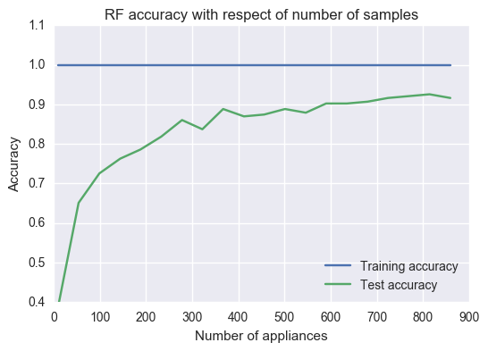**Figure 6- RF classifier accuracy with increasing number of samples**

* Processing of data: Identifying intervals of steady state behavior signals for each appliance would be very useful to improve the accuracy of the classifiers. Therefore, further work should be done to process the data before training the classifiers.
* Adding engineered features: While an image recognition approach was employed in this analysis, the data of currents and voltages contain a lot of useful information for classification. The next step would be to find ways to combine both types of features.
* Apply deep learning algorithms: Since we are working with images, and given that the machine learning community has done impressive work in image recognition using neural networks, it would be worth it to apply a specialized deep learning architecture to the dataset of images produced. However, in order to do produce meaningful better results, we will need more samples per appliance type.

# REFERENCES

1. Sameer Kwatra, Jennifer Amann, and Harvey Sachs, “Miscellaneous energy loads in Buildinds”, American Council for an Energy- efficient economy (June 2013)
2. “DOE seeking information on miscellaneous electrical loads research and development topics” <http://energy.gov/eere/buildings/articles/doe-seeking-information-miscellaneous-electrical-loads-research-and> [Online] Available (Accessed 12/8/2016)
3. J. Gao, S. Giri, E. C. Kara, and M. Berg´es, “Plaid: A public dataset of high-resolution electrical appliance measurements for load identiﬁcation research: Demo abstract,” in Proceedings of the 1stACM Conference on Embedded Systems for Energy-Efﬁcient Buildings, BuildSys ’14, (New York, NY, USA), pp. 198–199, ACM, 2014.
4. Scikit learn “Machine learning in Python” <http://scikit-learn.org/stable/> [Online] Available (Accessed 12/09/2016)